File permission Task

Create a file with .txt extension (/home/demo.txt). Change the permission set of that file, so that any user can read it, group can read/write & owner can read/write/execute it.

Step 1 :Create Directory----mkdir home

Step 2 :Create File in the directory --- touch /home/demo.txt

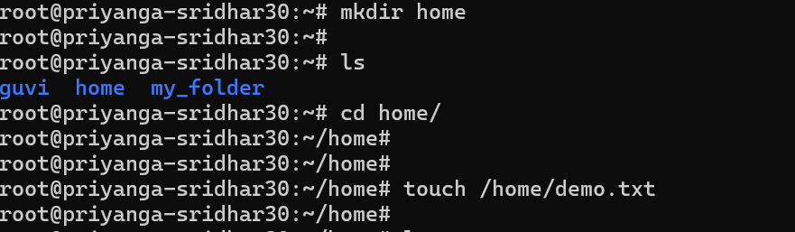

**Owner (User)**: rwx = 4 + 2 + 1 = 7

**Group**: rw- = 4 + 2 + 0 = 6

**Others**: r-- = 4 + 0 + 0 = 4

